Generation of Multipotent Induced Neural Crest by Direct Reprogramming of Human Postnatal Fibroblasts with a Single Transcription Factor

Summary
Neural crest (NC) generates diverse lineages including peripheral neurons, glia, melanocytes, and mesenchymal derivatives. Isolating multipotent human NC has proven challenging, limiting our ability to understand NC development and model NC-associated disorders. Here, we report direct reprogramming of human fibroblasts into induced neural crest (iNC) cells by overexpression of a single transcription factor, SOX10, in combination with environmental cues including WNT activation. iNC cells possess extensive capacity for migration in vivo, and single iNC clones can differentiate into the four main NC lineages. We further identified a cell surface marker for prospective isolation of iNCs, which was used to generate and purify iNCs from familial dysautonomia (FD) patient fibroblasts. FD-iNC cells displayed defects in cellular migration and alternative mRNA splicing, providing insights into FD pathogenesis. Thus, this study provides an accessible platform for studying NC biology and disease through rapid and efficient reprogramming of human postnatal fibroblasts.

Graphical Abstract
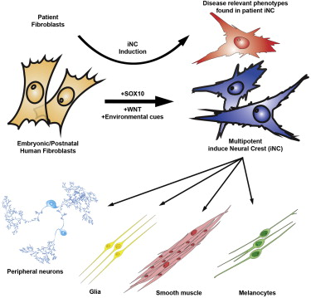

Reverting to Type: Using stem cells to better understand familial dysutonomia

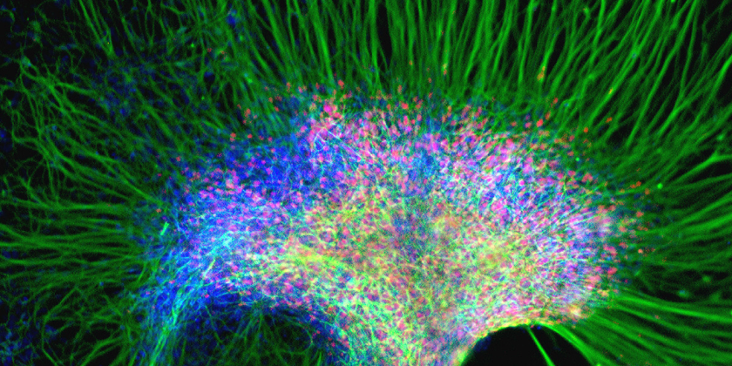

Stem cell researchers have found a way to quickly turn back the clocks for the cells of rare disease patients in order to better understand their condition
Researchers from John Hopkins have successfully reprogrammed a patient’s skin cells to mimic many of the biological features typical of the rare genetic disorder familial dysutonomia. These development will allow researchers to develop neural crest cells from the patient’s own skin cells. The researchers will no longer need to first create induced pluripotent stem cells (iPS) from patient skin cells, which could later become crest cells. This will reduce the timeline for creating crest cells by nearly 7 months, as well as create cells that more closely resemble those of the patients.
Neural crest cells are an important part of prenatal development, and form many important structures, ranging from parts of the nervous system, to the bone in the skull and jaw, and pigment producing skin cells. Familial dysautonomia, a disorder with fewer than 500 patients worldwide, is caused by dysfunctioning crest cells and can affect the patient’s nerves, resulting an inability to regulate emotions, blood pressure, and bowel movements.
It seems as though the neural crest cells created directly from patient skin cells show more of the characteristics of familial dysautonomia than the neural crest cells we created previously from induced pluripotent stem cells. That means they should be better predictors of what happens in a particular familial dysautonomia patient, and whether or not a potential treatment will work for any given individual.”Gabsang Lee, Ph.D., Senior author and assistant professor of neurology at the Institute for Cell Engineering
In an initial experiment, researchers tested a series of molecular signal combinations and were able to create a system by which 2% of skin cells grown by the team had their Sox10 gene activated by the treatment. Using a cocktail of chemical additives, they were then able to ‘rewind’ their genetic memory, resulting in cells showing gene activity similar to neural crest cells. This technique was then applied to skin cells taken from patients and found that the results produced were similar to their early experiments.
The importance of creating crest cells comes from the fact that most of a patient’s crest cells have generally gone by the time they a born, making it difficult for researchers to study how the cells cause various disorders associated with them.

